Success story
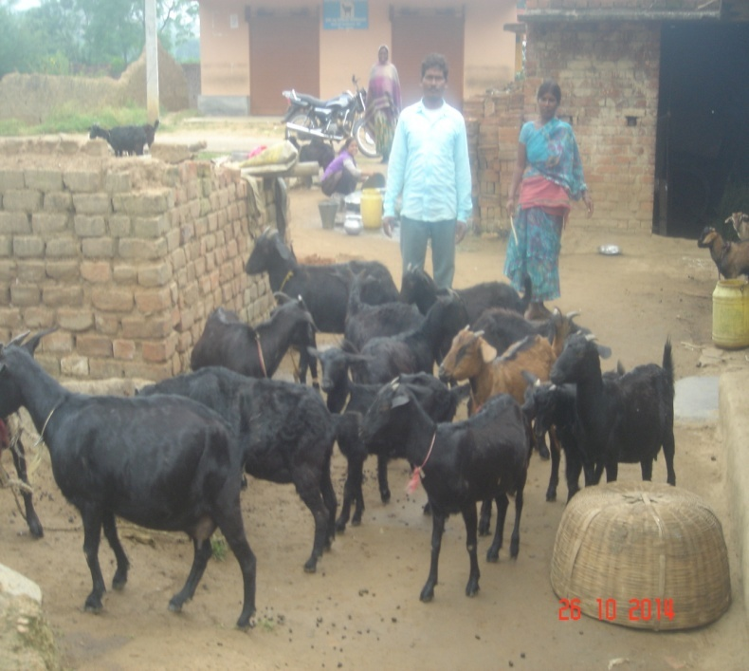
Sri Jitan pahan Oraon is a landless farmer of village Bantola, Chamguru, Dist Ranchi. He has three children besides his sister. He is class v passed. He was laborious student, but due to early demise of his parents he had to give up school. He had no means to feed his family members. So he was forced to work as laborers. One day his wife suggested him to keep goats for subsidiary income. He purchased two female goats in 2006. After one year he got 2 adult male goat from which he got Rs 3500=00 form its sale. This additional income made him to think for keeping more goats. So he had purchased three more adults female goats but at the same time he encounters death of 2 goats. In the mean time we visited villages Chamguru to open a center. We were discussing with gram pradhan about opening a center. During discussion, he was also present. All people requested to make arrangement to reduce mortality rate which was as high as 40%. It was decided to open the center. Jitan pahan Oraon thus came to our contact. He has also taken 3 days training at RVC goat farm. We provided him health care like dipping, deworming, vaccination and supplementary feeding. His flock grew and grew and at present he has 21 heads with no death since last two years. He is now earning Rs 30000-35000 per year. He is using this amount for education of his children and wellbeing of his family.

